# **Michael Gonzalez DSC 680 Fall 2020**

**Professor Williams**

Is it Possible to Predict Heart Disease with Machine Learning?

# Abstract

The selected dataset comes from the Kaggle competition section that used UCI’s data of heart disease information. The dataset has fourteen attributes that are based on the profiles of different patients who are dealing with heart disease. This dataset has many useful data points that include blood pressure, heart rates at different times and if the patient was a smoker? These data points will help in giving insights on the factors that can lead to developing heart disease. Below is a link to the dataset:

<https://www.kaggle.com/ronitf/heart-disease-uci>

I am planning to use different approaches to predicting the presence of heart disease. Boiling down this project, I see this being a classification problem in predicting heart disease in men and women of different age groups and lifestyles. I am planning on using classification algorithms like random forests, ada boost and logistic regression. Using different approaches will give an insightful image of which one works and the differences of the results. This will lead me to have a better understanding of the results and how to handle them.

I also noticed that the code book has well documented information for the results of this dataset. The information needs some modification to make it understandable for the public. In the appendix section of this paper, I will include the original version of the code book. The appendix is located after the references section of this paper.

# Background

The reason why I selected a heart disease data for my first project, it relates to the healthcare industry that is currently benefiting from data science. I also wanted to focus on heart disease since it is a common disease in my father’s family and in most Hispanic families. In my first project, I am hoping to use machine learning to help in predicting the presence of heart disease by common traits.

# Method Used

Starting with the dataset from Kaggle, which was in a CSV format. I decided to use the Pandas package to read and transform the dataset. I have also used the Seaborn and Matplotlib packages to create data visualizations that will help in answering my research question. Going back to the dataset, I want to talk about it and give you the reader a better understanding of it. This dataset has 14 variables and 303 rows of data that included anonymized health profiles of past medical patients.

# Updating Data Types:

I looked at the data types through the Pandas info function to see if the data types are in formats that will be useful. I noticed that some of the data types were not in a useful format, and I would need to correct them. I used the Pandas package to correct the data types of sex, target, cp, resting ecg, thal, fasting blood sugar, ca, exang and slope to a categorical format. This will make it easier to understand the results through data visualizations. After, I used the Pandas head function to see the first rows of the dataset to check the order of the data.

# Updating Dataset’s Columns:

I noticed the columns were not matching the code book. For consistency sake, I wanted to rename the columns to match what was seen in the code book. This will make everything consistent and orderly. By not doing this, will result to inconsistent results that would not be helpful to anyone. This section was straightforward since the Pandas package has a rename function that allowed me to rename the mismatched columns.

The columns that needed to be renamed are listed below:

cp became chestpain

trestbp became restingbp

fbs became fastingbloodsug

exang became angina

oldpeak became exinduced_depression

thalach became max_heartrate

ca became numofmajorvessels

Once the renaming of the columns was done. I noticed some of the categorial variables needed to be converted to numerical variables. To make it easier for me when I need to use them for model fitting.

# Updating Dataset’s Variables:

There were eight variables that needed to go through this process of conversion. I knew this would cause me to work harder in the beginning, but in the long run this process would be beneficial.

The variables that needed to be converted are listed below:

sex was 0 for Female became Female and 1 for Male became Male

fastbloodsug was 0 for Normal became Normal and 1 for High became High

restecg was 0 for Normal became Normal, 1 for Abnormal became Abnormal and 2 for Very Abnormal became Very Abnormal

angina was 0 for No became No and 1 for Yes became Yes

target was 0 for No Disease became No Disease and 1 for Disease became Disease

slope was 0 for Upslope became Upslope, 1 for Flat became Flat and 2 for Downslope became Downslope

chestpain was 0 for Asymptomatic became Asymptomatic, 1 for Non Anginal became Non Anginal, 2 for Atypical Angina became Atypical Angina and 3 for Typical Angina became Typical Angina

After converting the eight variables from numerical to categorical. I wanted to check for any missing data. Unfortunately, there was one variable that had four areas of missing data and it was the restecg variable. I decided to drop this one.

# Data Visualizations

In this section, I will display a few visualizations that were used to help me understand the dataset. As I mentioned earlier in this paper, I used the Seaborn and Matplotlib packages to create these visualizations. For the first visualization, it was a histogram that displays the amount of men and women who might or might not have the presence of heart disease in their body. Seen in Figure 1. Looking at the histogram’s legend, blue represents the presence of heart disease. Orange represents no presence of heart disease. When looking at the male section of the visualization, there is a clear difference between men who have the presence of heart disease and the men who do not. In the female section of the visualization, there is also a clear difference between women who have the presence of heart disease and the women who do not. This was a good base for me to see how many people had the presence of heart disease between the two genders. From this histogram I saw that men are more likely to have the presence of heart disease compared to women.

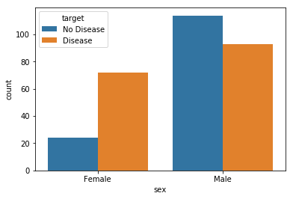

Figure 1: Histogram of Males and Females who might have heart disease or not.

The next visualization is a box plot that gave me more insights of the data between males and females. Continuing with the dataset that is comparing males and females who have high blood sugar levels and who have normal blood sugar levels. The reason for this comparison was having high blood sugar levels is one of many indicators that lead to having heart disease. The box plot that displays the comparison of which gender might have high blood sugar levels, can be seen in Figure 2.

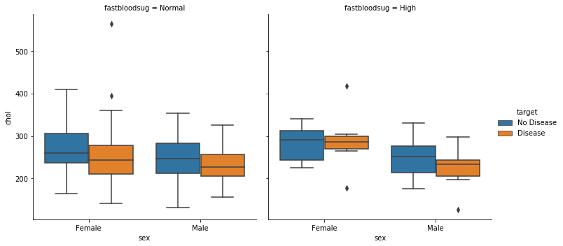

Figure 2: Box Plot of Males and Females who have high blood sugar levels and normal levels with the presence of heart disease or not.

It seems that there is an overall distribution of males and female who have the presence of heart disease or not that also have high and normal blood sugar levels.

In the violin plot, which is an unusual plot gave me a better understanding of how the heart rates are affected by having the presence of heart disease or not. This was injunction with the affects between males and females. Seen in Figure 3, the higher the heart rate could lead to a person having the presence of heart disease. The violin plot also displays men having high heart rates with the presence heart disease exceed the number of women who also have high heart rates with the presence heart disease.

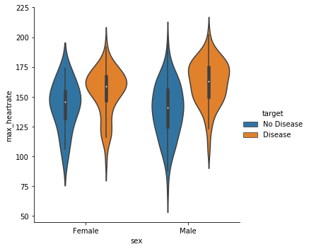

Figure 3: Violin Plot of Males and Females who have high heart rates with the presence of heart disease or not.

# Model Fitting

I experimented with three types of models for this project. I have selected the Random Forest Classifier in combination with Grid Search with Cross Validation. This combination gave me the best results for identifying the parameters to be used to validating the model. The way the parameters are found with grid search is done with four selectors, which are criterion, max_depth, max_features and n_estimators. The results of my best parameters were criterion was best with gini, max_depth was 4, max_features was auto and n_estimators was 10. What does this all mean?

The criterion has a selection between entropy and gini, which changes your results and accuracy. The max_depth has a selection from 4 to 8 and just criterion it can change your results. The max_features has a selection of auto, sqrt, and log, which changes your results depending the selection of max_features. The n_estimators has a selection range from 1 to 10. Once Grid Search gave me the best parameters, I calculated the prediction with the test split and the area under the curve score. My score came to be 88 percent accurate, which is great. I validated my score again with Grid Search and Random Forest Classifier and it is seen in Figure 4.

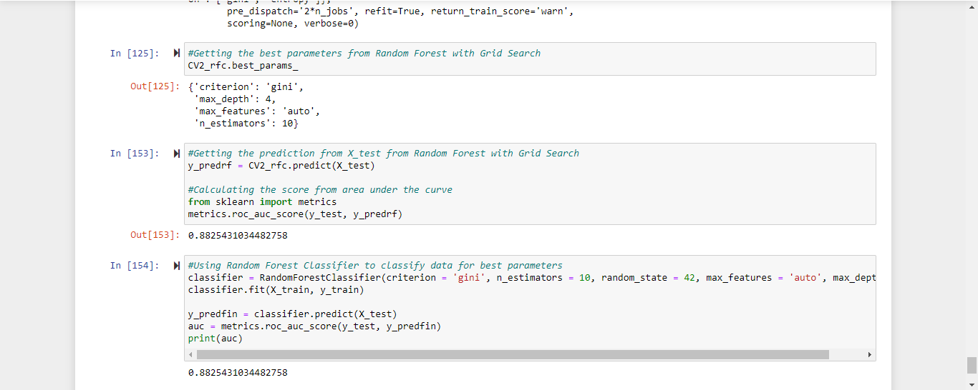

Figure 4: Validating the Random Forest Model with Grid Search.

As I mentioned earlier that this model has a high accuracy rate which is 88%. The reason for the high accuracy rate could be due to the size of the selected dataset, which compared to others could be small. Either way the model shows that it was able to reach a high accuracy rate.

# Conclusion

The focus of this project was to fit a model that was able to predict the presence of heart disease based on anonymized health profiles of past medical patients. I had experimented with three different classification models to find and analyze the best parameters used for making predictions. Out of the three classification models selected for this project, the Random Forest Classifier with Grid Search was the best with an accuracy rate of 88%. Since the size of the selected dataset was relatively small, the experiment models were able to predict with high accuracy rates.

# References

[1] Bhanot, K. Predicting presence of Heart Diseases using Machine Learning. February 12, 2019. <https://towardsdatascience.com/predicting-presence-of-heart-diseases-using-machine-learning-36f00f3edb2c> (Article on using machine learning to predict heart disease)

[2] Green, W. Machine Learning with a Heart: Predicting Heart Disease. July 31, 2018. <https://medium.com/@dskswu/machine-learning-with-a-heart-predicting-heart-disease-b2e9f24fee84> (Article on using machine learning to find the presence of heart disease)

[3] Muthuvel, Marimuthu & Sivaraju, Deivarani & Ramamoorthy, Gayathri. (2019). Analysis of Heart Disease Prediction using Various Machine Learning Techniques. <https://www.researchgate.net/publication/330981991_Analysis_of_Heart_Disease_Prediction_using_Various_Machine_Learning_Techniques> (Article on the analysis of different machine learning techniques on heart disease predictions)

[4] Nashif, S., Raihan, Md.R., Islam, Md.R. and Imam, M.H. (2018) Heart Disease Detection by Using Machine Learning Algorithms and a Real-Time Cardiovascular Health Monitoring System. <https://www.scirp.org/html/14-1560633_88650.htm> (Article on detecting heart disease traits with machine learning)

[5] European Society of Cardiology. (2019, May 13). Machine learning overtakes humans in predicting early death or heart attack: Machine algorithm uses 85 variables to calculate risk in individuals. <https://www.sciencedaily.com/releases/2019/05/190513081412.htm> (Article on the benefits of using machine learning to predict heart disease)

[6] S. Mohan, C. Thirumalai and G. Srivastava, "Effective Heart Disease Prediction Using Hybrid Machine Learning Techniques," in IEEE Access, vol. 7, pp. 81542-81554, 2019, doi: 10.1109/ACCESS.2019.2923707. <https://ieeexplore.ieee.org/document/8740989> (Article on using hybrid machine learning techniques on predicting heart disease)

[7] Sharma, H. (2017). Prediction of Heart Disease using Machine Learning Algorithms: A Survey. <https://www.semanticscholar.org/paper/Prediction-of-Heart-Disease-using-Machine-Learning-Sharma/d0a5d4b8e8da3ee2a6bf8ac5d44196fb0365cf1c?p2df> (Article on the survey results of the effectiveness on using machine learning for predicting heart disease)

[8] Amin Ul Haq, Jian Ping Li, Muhammad Hammad Memon, Shah Nazir, Ruinan Sun, "A Hybrid Intelligent System Framework for the Prediction of Heart Disease Using Machine Learning Algorithms", Mobile Information Systems, vol. 2018, Article ID 3860146, 21 pages, 2018. <https://www.hindawi.com/journals/misy/2018/3860146/> (Article on using a hybrid framework for using machine learning techniques to predict heart disease)

[9] Ronit. Heart Disease UCI Dataset. Kaggle. N.D. <https://www.kaggle.com/ronitf/heart-disease-uci> (Dataset of UCI’s heart disease information)

[10] Apurb Rajdhan , Avi Agarwal , Milan Sai , Dundigalla Ravi, Dr. Poonam Ghuli, 2020, Heart Disease Prediction using Machine Learning, INTERNATIONAL JOURNAL OF ENGINEERING RESEARCH & TECHNOLOGY (IJERT) Volume 09, Issue 04 (April 2020). <https://www.ijert.org/heart-disease-prediction-using-machine-learning> (Article on predicting heart disease with machine learning techniques)

**Appendix**

Code Book of Kaggle/UCI Heart Disease Dataset

This database contains 76 attributes, but all published experiments refer to using a subset of 14 of them. In particular, the Cleveland database is the only one that has been used by ML researchers to this date. The "goal" field refers to the presence of heart disease in the patient. It is integer valued from 0 (no presence) to 4.

Attribute Information:

age

sex

chest pain type (4 values)

resting blood pressure

serum cholestoral in mg/dl

fasting blood sugar > 120 mg/dl

resting electrocardiographic results (values 0,1,2)

maximum heart rate achieved

exercise induced angina

oldpeak = ST depression induced by exercise relative to rest

the slope of the peak exercise ST segment

number of major vessels (0-3) colored by flourosopy

thal: 3 = normal; 6 = fixed defect; 7 = reversable defect

The names and social security numbers of the patients were recently removed from the database, replaced with dummy values. One file has been "processed", that one containing the Cleveland database. All four unprocessed files also exist in this directory.

Acknowledgements

Creators:

Hungarian Institute of Cardiology. Budapest: Andras Janosi, M.D.

University Hospital, Zurich, Switzerland: William Steinbrunn, M.D.

University Hospital, Basel, Switzerland: Matthias Pfisterer, M.D.

V.A. Medical Center, Long Beach and Cleveland Clinic Foundation: Robert Detrano, M.D., Ph.D.

Donor:

David W. Aha (aha '@' ics.uci.edu) (714) 856-8779

Inspiration

Experiments with the Cleveland database have concentrated on simply attempting to distinguish presence (values 1,2,3,4) from absence (value 0).

**10 Questions**

1. Why are men more likely to have heart disease compared to women?
2. What are the common traits for women developing heat disease?
3. Could a person’s lifestyle lead to developing heart disease?
4. Could heart disease be a result of unhealthy eating habits?
5. Does having a high blood sugar levels lead to heart disease?
6. Does having a higher heart rate be a result of heart disease?
7. What causes men with heart disease to have higher heart rates?
8. Does having chest pains be a sign of heart disease?
9. Does having high cholesterol levels be a sign of heart disease?
10. What can people do to prevent developing heart disease?